Lab 1:
Create X lock for row where film_id = 1.
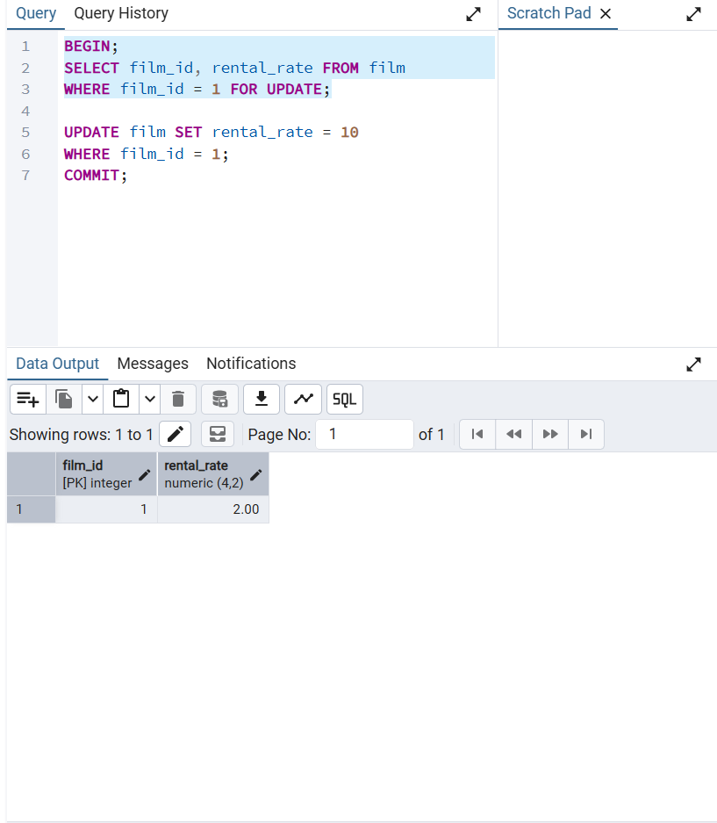

Another session is waiting for the first session.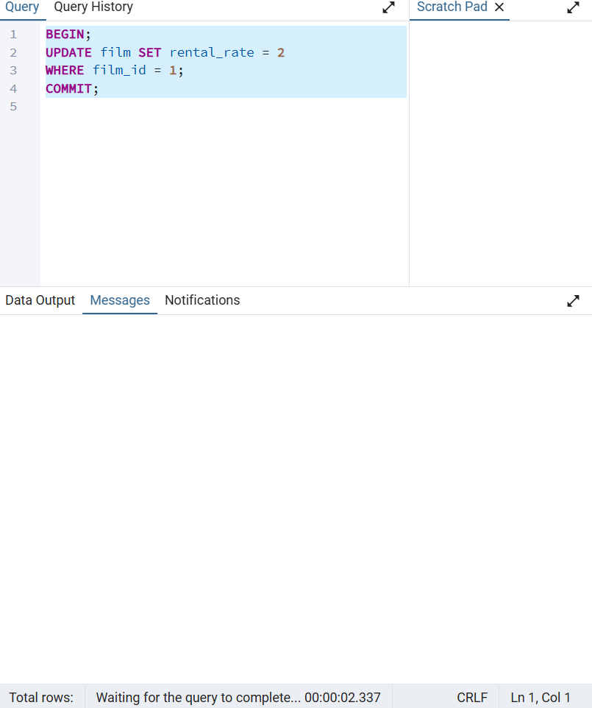

When the session 1 completes, session 2 starts to run and complete immidiately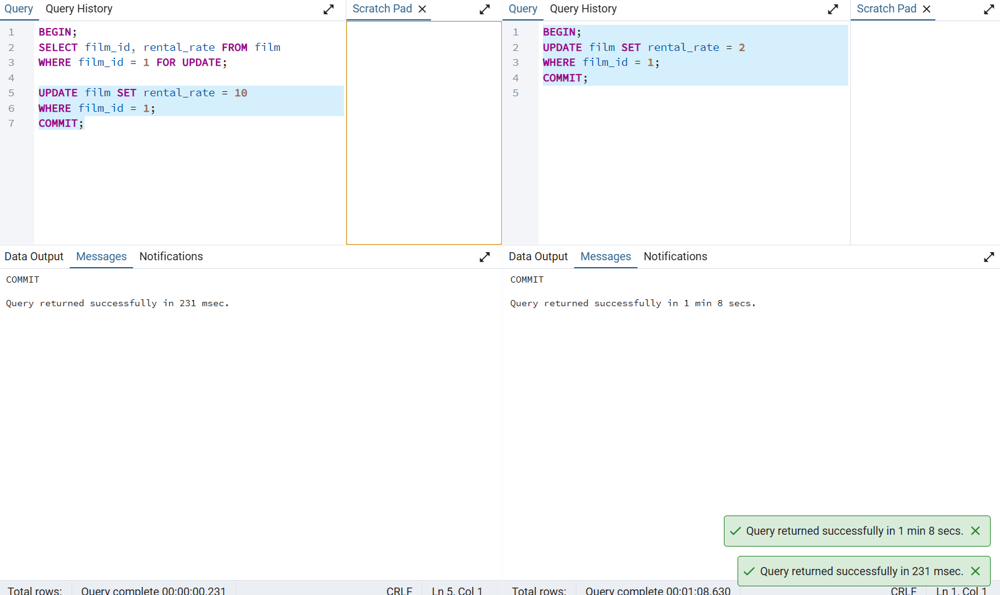

Lab 2:
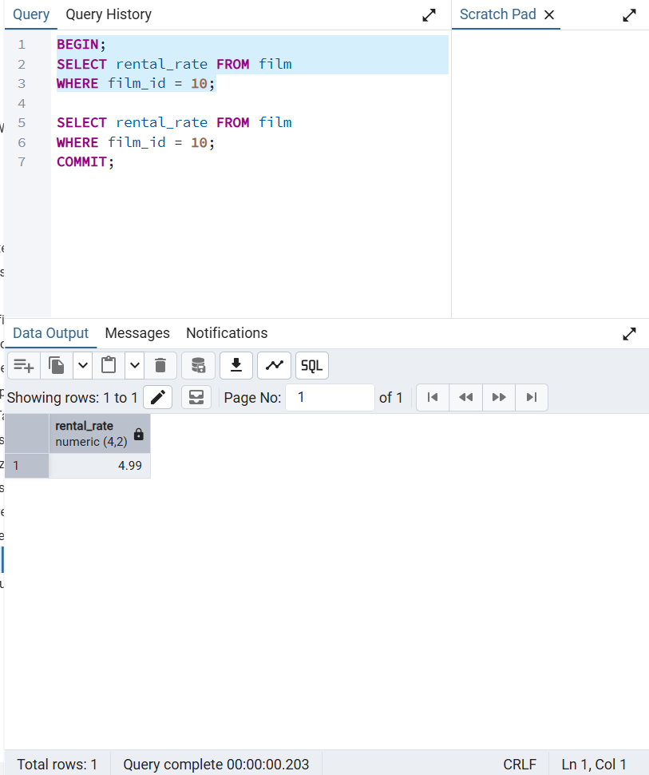
First read show rental_rate = 4.99
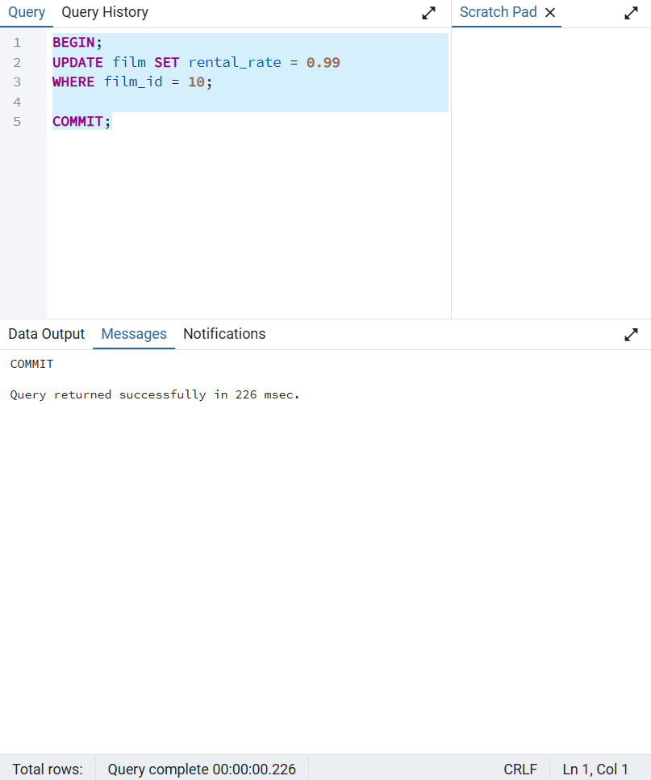
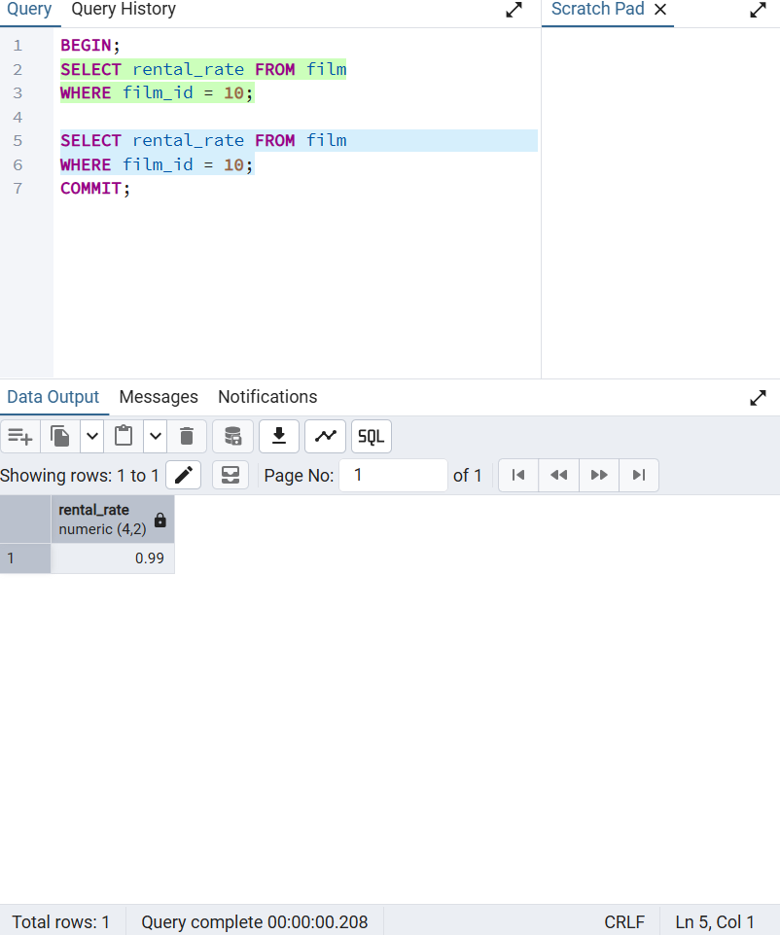
Second time read show the value had changed.
Lab 3
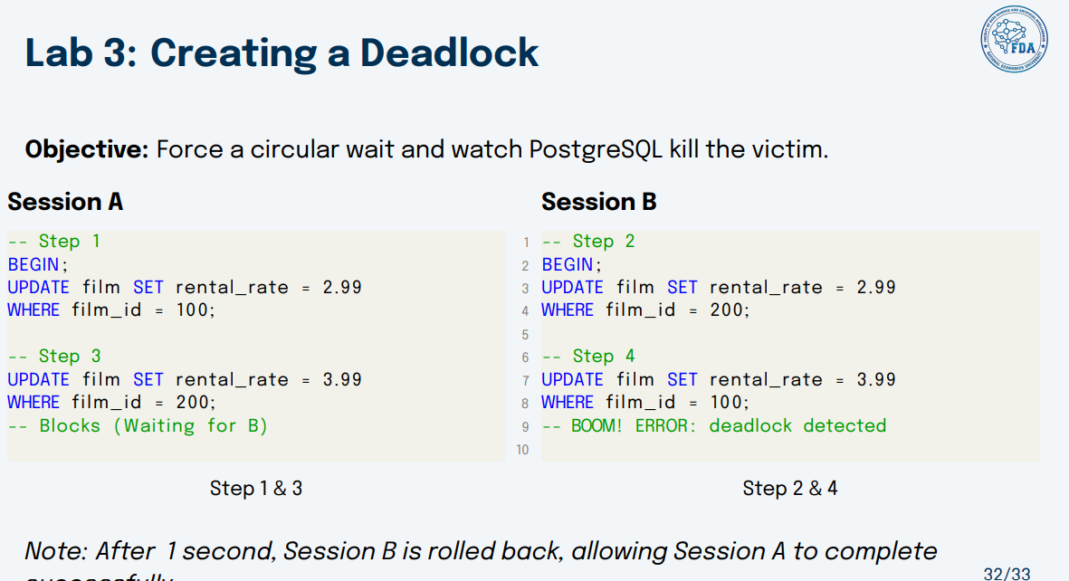
STEP 1
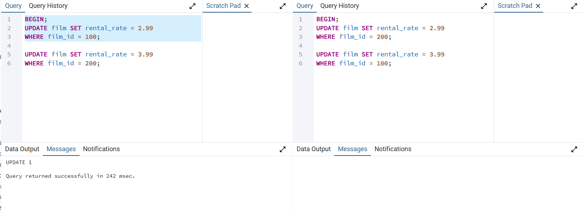
Bind a lock in row film_id = 100
STEP 2
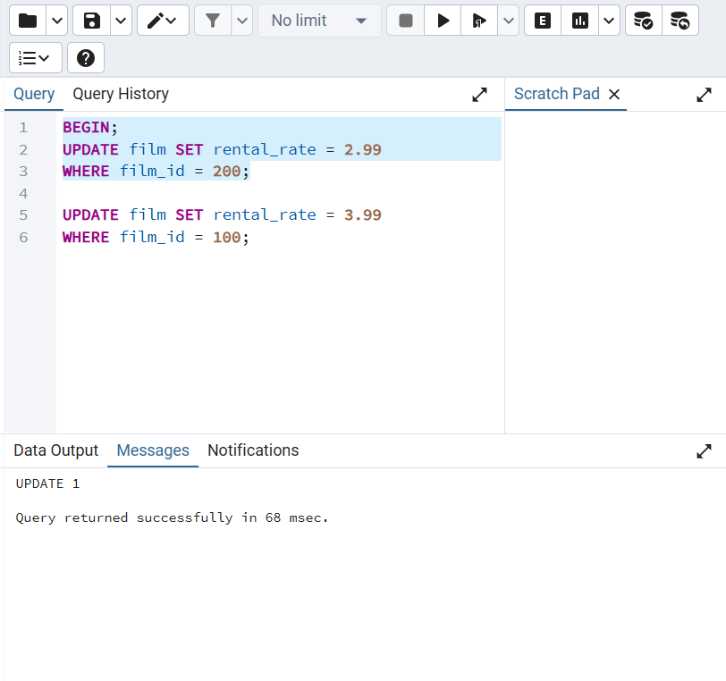
Bind a lock in row film_id = 200

STEP 3
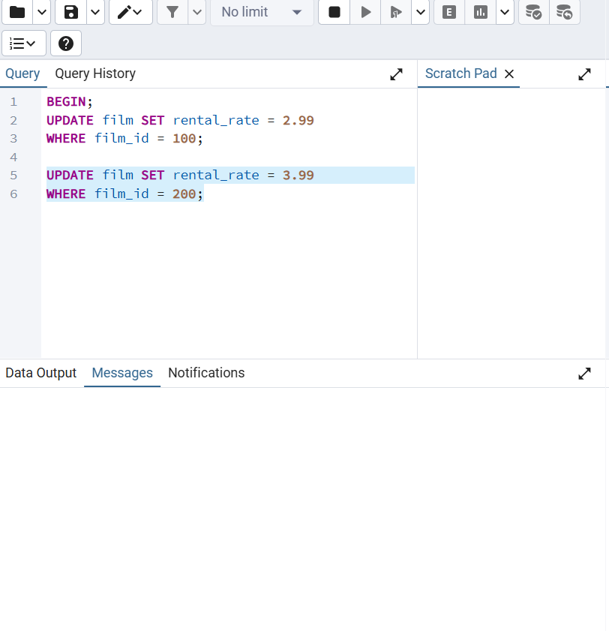
Run an update on the locked row film_id = 200 in the first session, it waits for the session 2 done it work then update.
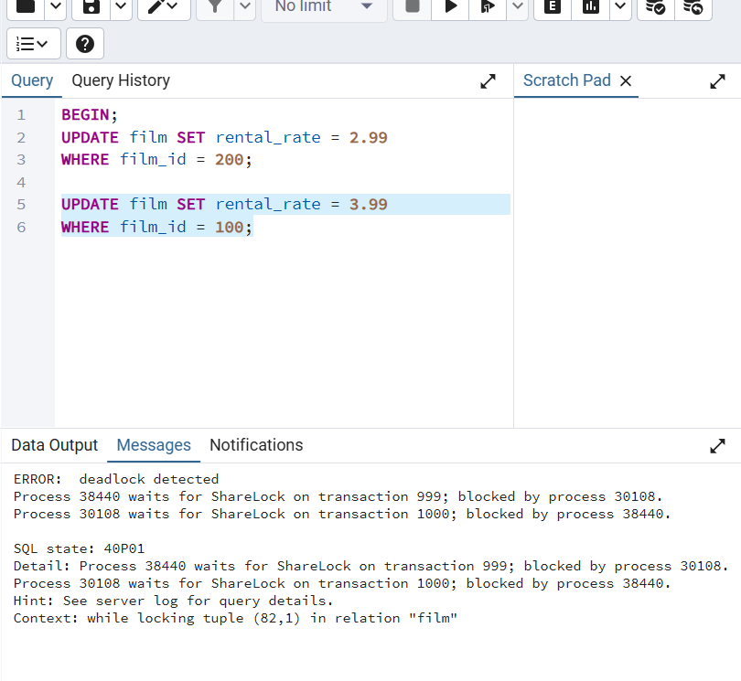
But because the session 2 have a lock on row film_id = 100 so it also need to wait for session 1 to finish running -> deadlock detected.

Session 2 wait for session 1 to complete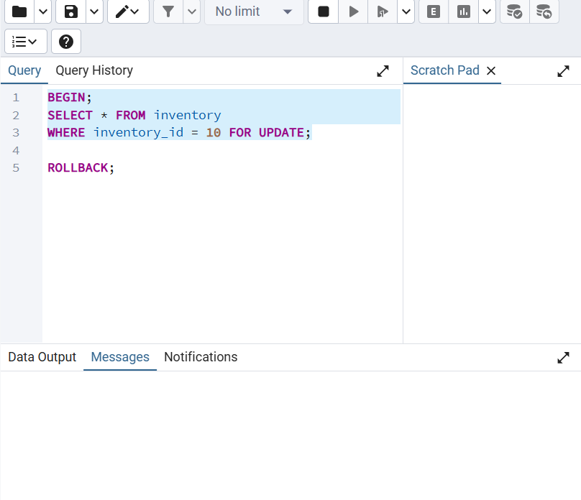
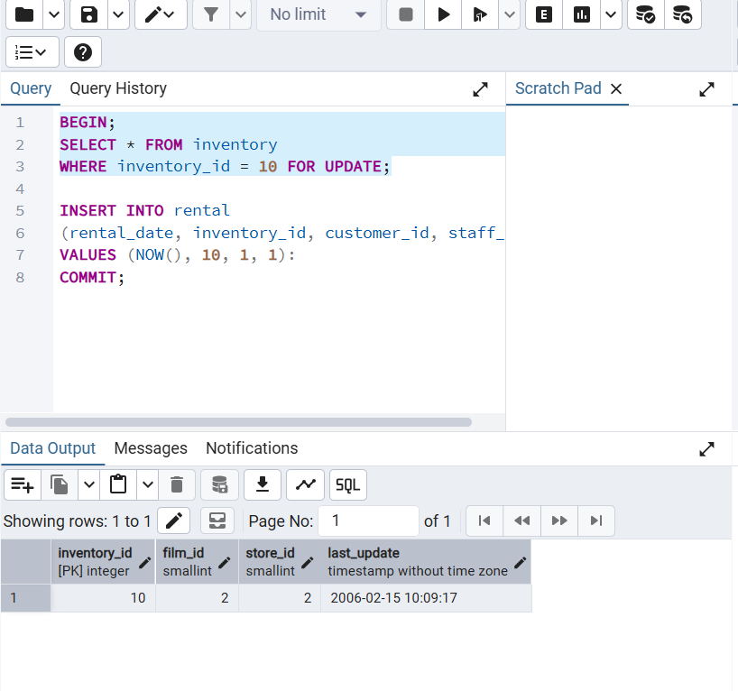
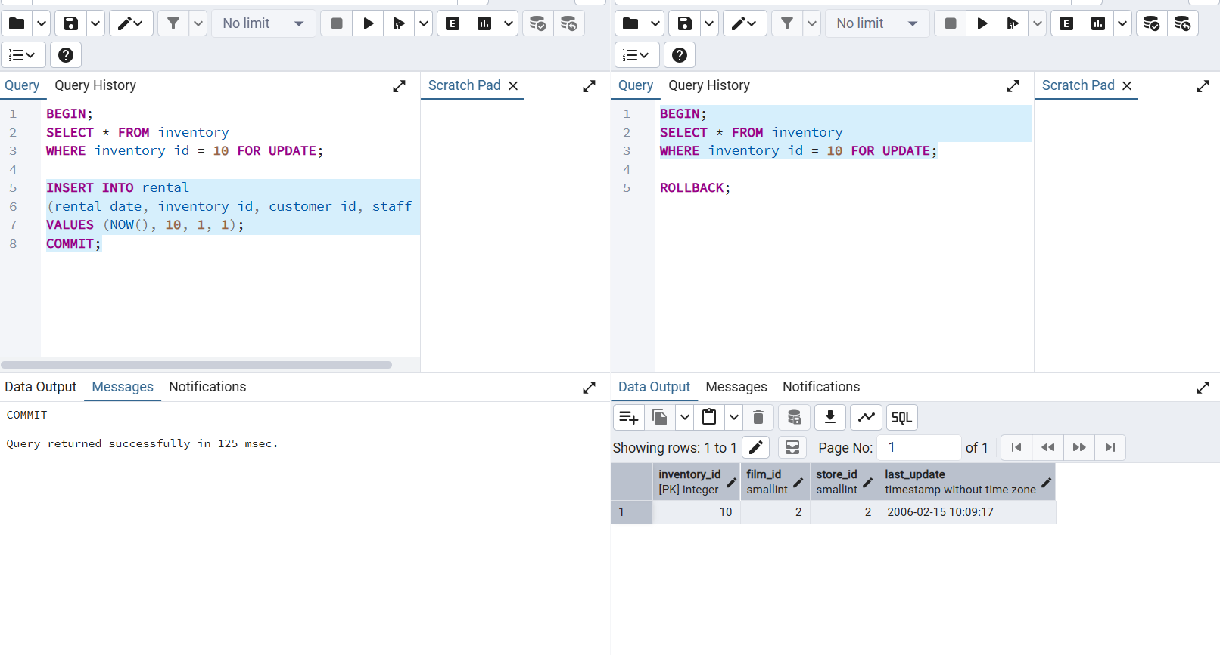
After session 1 done running code, session 2 start it query.

